[Project Name]
Deployment Model

Date | [April 12, 2010]
Version | [1.1]
Status | [Approved]
Author | [Vo Minh Tan, Leader]
Reviewed by | [Le Tat Hai, Director]
Approved by | [Nguyen Thi Thanh Thuy, Director]

Revision History

Date | Version | Description | Author
< May 28, 2011> | <1.0> | <Create> | < Vo Minh Tan >
< June 8, 2011> | <1.1> | <Update > | < Vo Minh Tan >
Table of Contents

1 Introduction 7
1.1 Purpose 7
1.2 Scope 7
1.3 Definitions, Acronyms and Abbreviations 7
1.4 References 7
1.5 Overview 7
2 Deployment 8
2.1 Component Model 8
2.1.1 LAN Components 8
2.1.1.1 BookStoreOrder Application 9
2.1.1.2 LAN SQL Server 9
2.1.1.3 Orders Database 9
2.1.2 Web Server Components 9
2.1.2.1 LAN 10
2.1.2.2 Web 10
2.1.2.3 ASP Pages 11
2.1.2.4 BookStore Database 11
2.1.2.5 COM+ Component Environment 11
2.1.2.6 Firewall 11
2.1.2.7 IIS 5.0 11
2.1.2.8 Web SQL Server 12
2.1.2.9 XSL Stylesheets 12
2.1.3 Common Components 12
2.1.3.1 Application Servers 12
2.1.3.1.1 .NET Server 12
2.1.3.2 Database 12
2.1.3.2.1 SQL Server 2000 12
2.1.3.2.2 SQL Server 2003 12
2.1.3.2.2.1 SQL Server Configuration 12
2.1.3.2.2.2 SQL Server 2003 12
2.1.3.3 Firewalls 12
2.1.3.3.1 Linux Firewall Software 12
2.1.3.3.2 Windows Firewall Software 13
2.1.3.4 HTTP Servers 13
2.1.3.4.1 IIS 5.0 13
2.1.3.4.2 IIS 6.0 13
2.1.3.5 Load Balancers 13
2.1.3.5.1 Windows Load Balancing Software 13
2.1.3.6 Mail Server 13
2.1.3.6.1 MS Exchange Server 13
2.1.3.7 Web Browsers 13
2.1.3.7.1 Internet Explorer 5.5 13
2.1.3.7.2 Internet Explorer 6.0 13
2.1.3.7.3 Netscape 7.0 13
2.2 Environment Model 13
2.2.1 Test Environment Model 13
2.2.1.1 TEST001 13
2.2.1.2 .NET 14
2.2.1.3 IIS 14
2.2.1.4 SQL Server 14
2.2.1.5 Windows 14
2.2.2 Development Environment Model 14
2.2.2.1 DEV001 14
2.2.2.2 DEV002 14
2.2.2.3 .NET Server 14
2.2.2.4 Apache Server 14
2.2.2.5 IIS 15
2.2.2.6 Linux 15
2.2.2.7 MailServer 15
2.2.2.8 SQL Server 15
2.2.2.9 Safari 15
2.2.2.10 Windows S/N 001 15
2.2.2.11 Windows S/N 002 15
2.3 Deployment Model 15
2.3.1 Head Office Deployment : HO Server Images 16
2.3.2 Head Office Deployment 16
2.3.2.1 192.168.0.3 18
2.3.2.2 192.168.02 19
2.3.2.3 216.239.46.95 19
2.3.2.4 216.239.46.96 19
2.3.2.5 Client Data Server 19
2.3.2.6 FRR01 19
2.3.2.7 HOES01 19
2.3.2.8 HOES02 19
2.3.2.9 HOFW 19
2.3.2.10 Mail Server 19
2.3.2.11 Web Server 19
2.3.2.12 WebDataServer 19
2.3.2.13 Clients 19
2.3.2.13.1 Office Client 1 19
2.3.2.13.1.1 Office Client PC 1 20
2.3.2.13.1.2 Application Component - TBA 20
2.3.2.13.1.3 Application 20
2.3.2.13.1.4 Web Browser 20
2.3.2.13.2 Office Client 2 20
2.3.2.14 Networking Equipment 20
2.3.2.14.1 192.168.0.1 20
2.3.2.14.2 192.168.0.2 21
2.3.2.14.3 216.239.46.185 21
2.3.2.14.4 <anonymous> 21
2.3.2.15 Servers 21
2.3.2.15.1 Text 21
2.3.2.15.2 Internal Database Server 22
2.3.2.15.2.1 Internal Data Config 22
2.3.2.15.2.2 Client Data 22
2.3.2.15.2.3 OS 22
2.3.2.15.2.4 Orders 22
2.3.2.15.3 Mail Server 22
2.3.2.15.3.1 Mail Exchange 23
2.3.2.15.3.2 Window OS 23
2.3.2.15.4 Web Database Server 23
2.3.2.15.4.1 Web 24
2.3.2.15.4.2 Books Data 24
2.3.2.15.4.3 WebDataOS 24
2.3.2.15.4.4 WebDatabase 24
2.3.2.15.5 Web Server 24
2.3.2.15.5.1 .Net Server 25
2.3.2.15.5.2 <anonymous> 25
2.3.2.15.5.3 <anonymous> 25
2.3.2.15.5.4 <anonymous> 25
2.3.2.15.5.5 Apache 25
2.3.2.15.5.6 Apache Configuration 26
2.3.2.15.5.7 Windows 26
2.3.3 Nodes 26
2.3.3.1 Computers 26
2.3.3.1.1 Clients 26
2.3.3.1.1.1 Desktop PC 26
2.3.3.1.1.2 LAN Client 26
2.3.3.1.1.3 Mail Client 26
2.3.3.1.1.4 Office Notebook 26
2.3.3.1.1.5 Remote Client 26
2.3.3.1.1.6 Remote Notebook 26
2.3.3.1.2 Servers 26
2.3.3.1.2.1 Dell PowerEdge 1650 26
2.3.3.1.2.2 Dell PowerEdge 2650 26
2.3.3.1.2.3 Dell PowerEdge 350 26
2.3.3.1.2.4 Dell PowerEdge 6650 27
2.3.3.1.2.5 HP ProLiant DL320 27
2.3.3.1.2.6 HP ProLiant DL360 27
2.3.3.1.2.7 HP ProLiant DL380 27
2.3.3.1.2.8 IBM xSeries 345 27
2.3.3.1.2.9 IBM xSeries 360 27
2.3.3.2 Networking 27
2.3.3.2.1 ADSL Router 27
2.3.3.2.2 Ethernet Adaptor 27
2.3.3.2.3 Ethernet Hub 27
2.3.3.2.4 Ethernet Switched Hub 27
2.3.3.2.5 Intel 19510 Frame Relay Router 28
2.3.3.2.6 Packet Filtering Router 28
2.3.3.2.7 WatchGuard III Firewall 28
2.3.4 Operating Systems 28
2.3.4.1 Mac OS X 28
2.3.4.2 RedHat Linux 9.0 28
2.3.4.3 Sun Linux JVM 1.4.0 28
2.3.4.4 Windows 2000 Professional 28
2.3.4.5 Windows 2000 Server 28
2.3.4.6 Windows 2003 Server 28
2.3.4.7 Windows XP Professional 28

Introduction

Purpose

[This section describes one or more physical network (hardware) configurations on which the software is deployed and run. It is a view of the Deployment Model. At a minimum for each configuration it should indicate the physical nodes (computers, CPUs) that execute the software, and their interconnections (bus, LAN, point-to-point, and so on). Also include a mapping of the processes of the Process View onto the physical nodes.

This view is OPTIONAL. Use this view only if the system is distributed across more than one node. Even in these cases, only use the deployment view where the distribution has architectural implications. For example, in cases where there is a single server and many clients, a deployment view only needed to delineate the responsibilities of the server and the clients as a class of nodes; there is no need to show every client node if they all have the same capabilities]

Scope

<Provide a short description of the software being specified and its purpose, including relevant benefits, objectives, and goals. Relate the software to corporate goals or business strategies. If a separate vision and scope document is available, refer to it rather than duplicating its contents here. An SRS that specifies the next release of an evolving product should contain its own scope statement as a subset of the long-term strategic product vision.>

Definitions, Acronyms and Abbreviations

No | Term | Description

References

<List any other documents or Web addresses to which this SRS refers. These may include user interface style guides, contracts, standards, system requirements specifications, use case documents, or a vision and scope document. Provide enough information so that the reader could access a copy of each reference, including title, author, version number, date, and source or location.>

Overview

Deployment

Component Model

Component Model

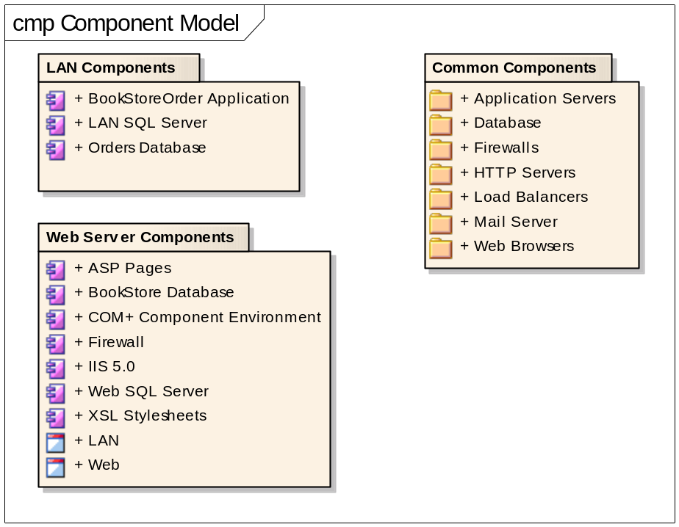
Figure 1: Component Model

LAN Components

LAN Components
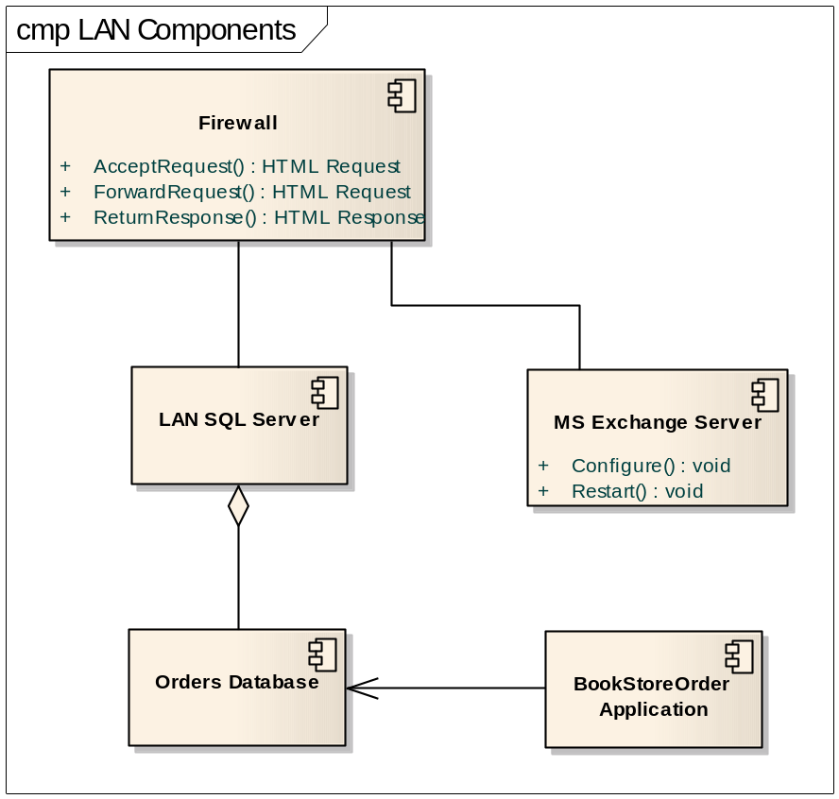
Figure 2: LAN Components

BookStoreOrder Application

LAN SQL Server

The SQL Server on the LAN side of the Firewall contains an updated replication of the transaction details and stock Items. It also contains the stock process details and user passwords etc.

Orders Database

Web Server Components

Server Components
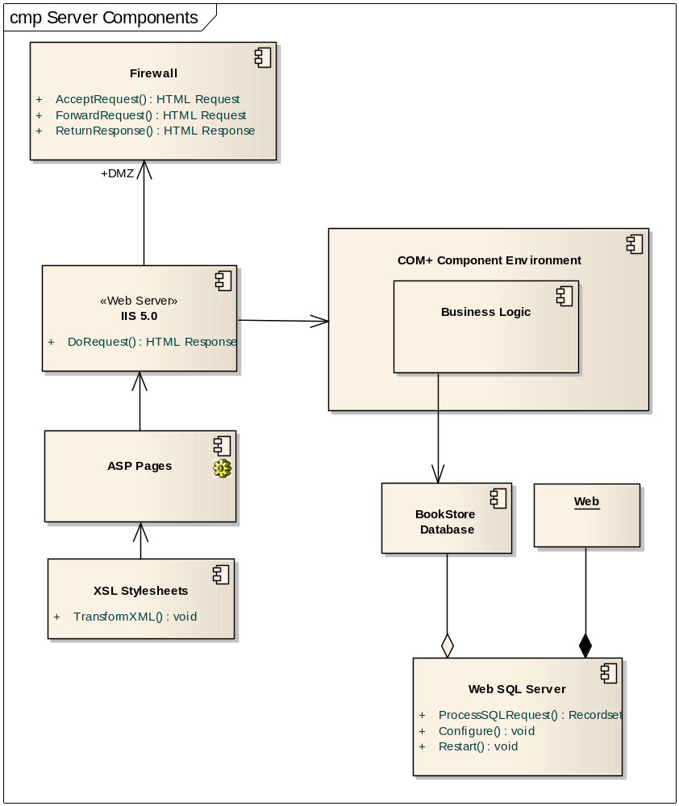
Figure 3: Server Components

LAN

Web

ASP Pages

ASP pages forward request to the appropriate business objects in the COM+ environment. Data sets returned from the business objects are transformed in to HTML pages using dynamic HTML and XSL style sheets.

BookStore Database

The BookStore database contains the Stock Items, transaction lists as well as the basic account entries, but not the client details. The full client details and access information like passwords etc. are only accessible on the LAN SQL Server. This is accessible from the DMZ side of the firewall.

COM+ Component Environment

The COM+ environment provides transaction management, session management, resource pooling, JIT activation of objects and other services which provide application scalability and reliability.

Firewall

The firewall provides a

Flow of Events
Basic Path
Basic path
1. HTTP request received2. Check if from valid address3. Valid HTTP passed to internal web server4. Invalid request discarded5. Response from internal address passed back to original sender

Post-condition
Illegal HTTP calls blocked
Status: Validated

Pre-condition
TCP/IP enabled
Status: Validated

IIS 5.0

The Web server used is IIS 5.0

Web SQL Server

XSL Stylesheets

Common Components

Application Servers

.NET Server

Database

SQL Server 2000

SQL Server 2003

SQL Server 2003

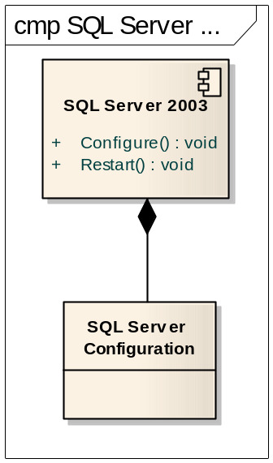
Figure 4: SQL Server 2003

SQL Server Configuration

SQL Server 2003

Firewalls

Linux Firewall Software

Windows Firewall Software

HTTP Servers

IIS 5.0

IIS 6.0

Load Balancers

Windows Load Balancing Software

Mail Server

MS Exchange Server

Web Browsers

Internet Explorer 5.5

Internet Explorer 6.0

Netscape 7.0

Environment Model

Test Environment Model

Test Environment Model

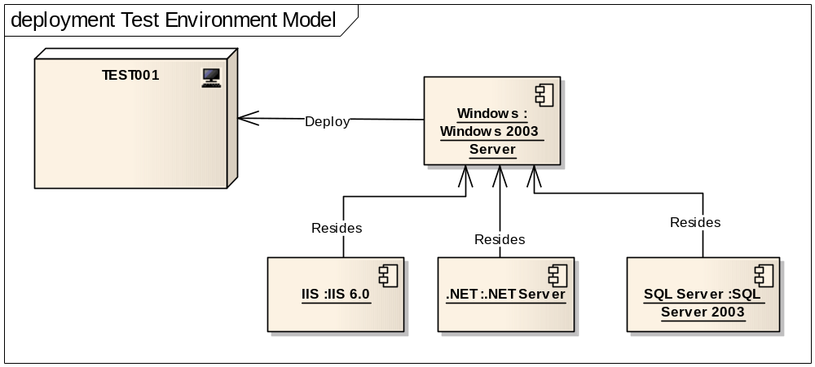
Figure 5: Test Environment Model

TEST001

.NET

IIS

SQL Server

Windows

Development Environment Model

Describes Logical Development Environment Model

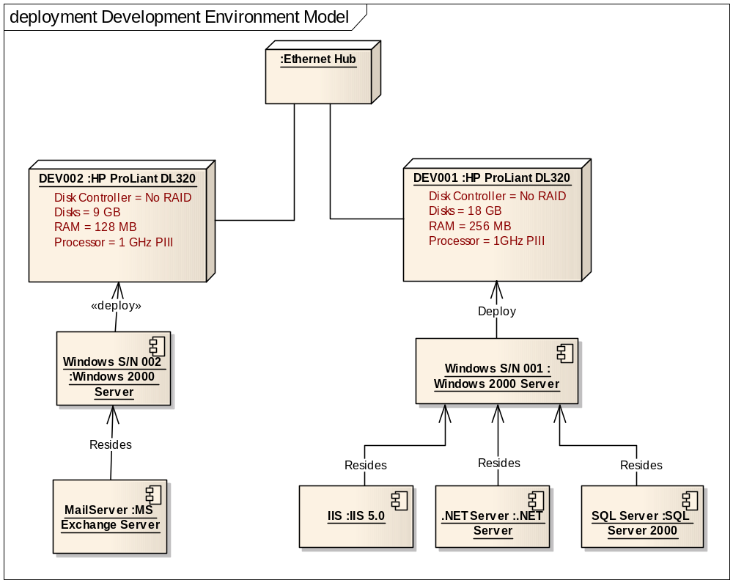
Figure 6: Development Environment Model

DEV001

DEV002

.NET Server

Apache Server

IIS

Linux

MailServer

SQL Server

Safari

Windows S/N 001

Windows S/N 002

Deployment Model

Describes Deployment Model at Physical place.
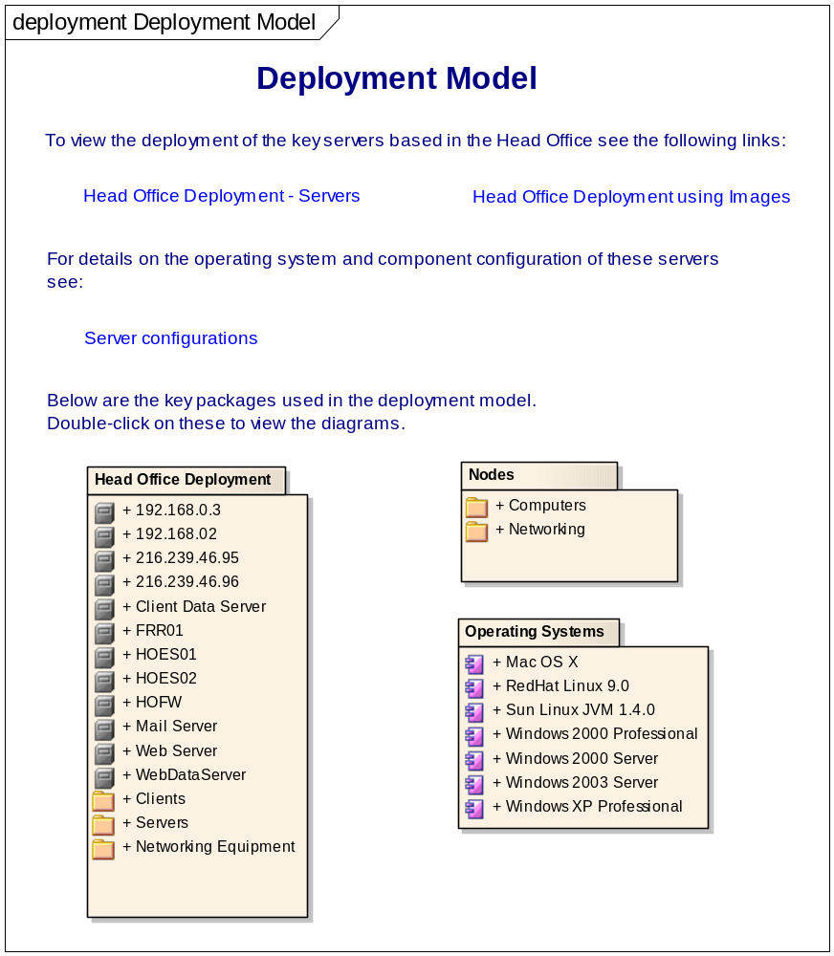
Figure 7: Deployment Model

Head Office Deployment: HO Server Images

Head Office Deployment using Images

Head Office Deployment

HO Server Images
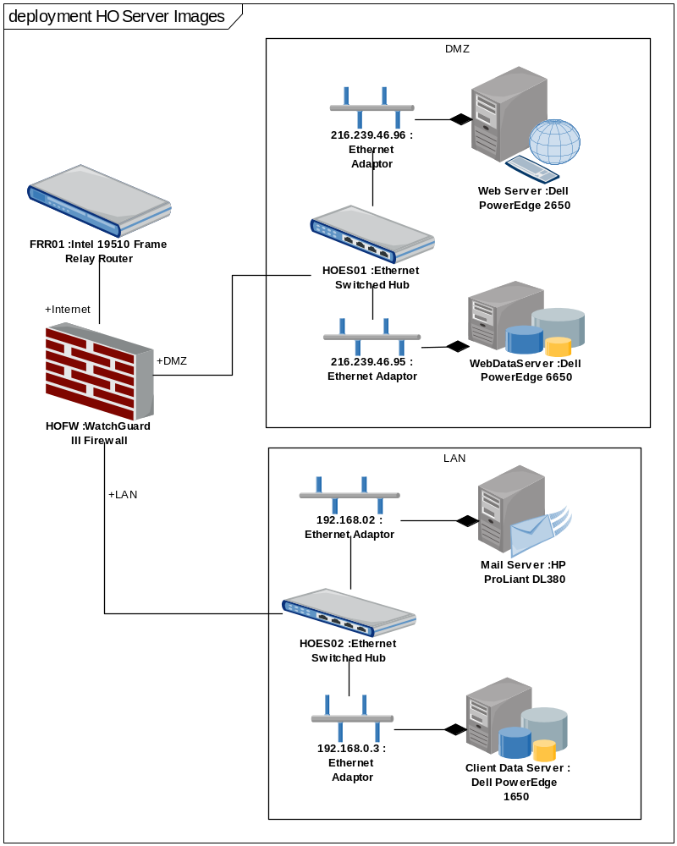
Figure 8: HO Server Images

HO Servers
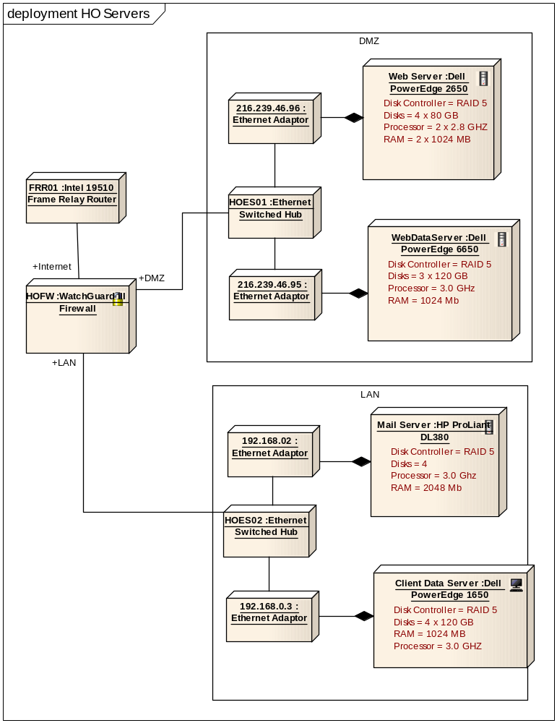
Figure 9: HO Servers

192.168.0.3

192.168.02

216.239.46.95

216.239.46.96

Client Data Server

This server holds the core client and transaction details and is kept on the secure LAN side of the firewall to ensure security.

FRR01

HOES01

HOES02

HOFW

Mail Server

Web Server

This machine supports the web site deployment of the application.

WebDataServer

Clients

Office Client 1

Office Client 1

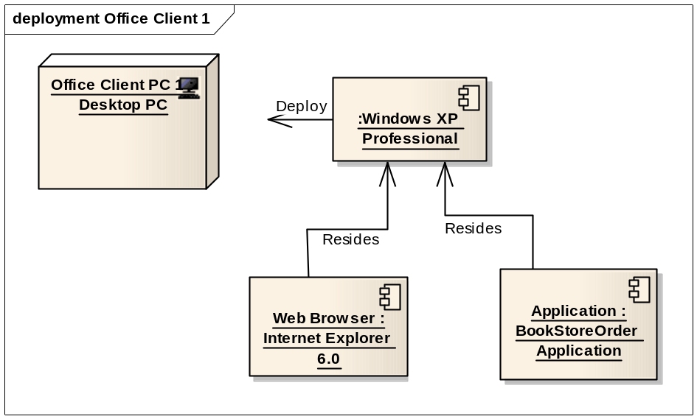
Figure 10: Office Client 1

Office Client PC 1

Application Component - TBA

Application

Web Browser

Office Client 2

Office Client 2

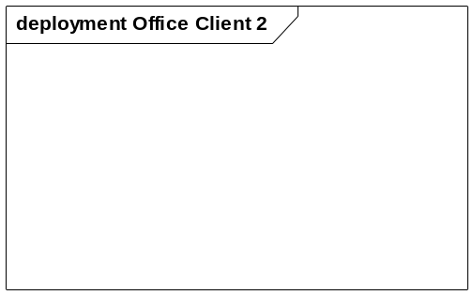
Figure 11: Office Client 2

Networking Equipment

192.168.0.1

192.168.0.2

216.239.46.185

<anonymous>

Servers

Servers

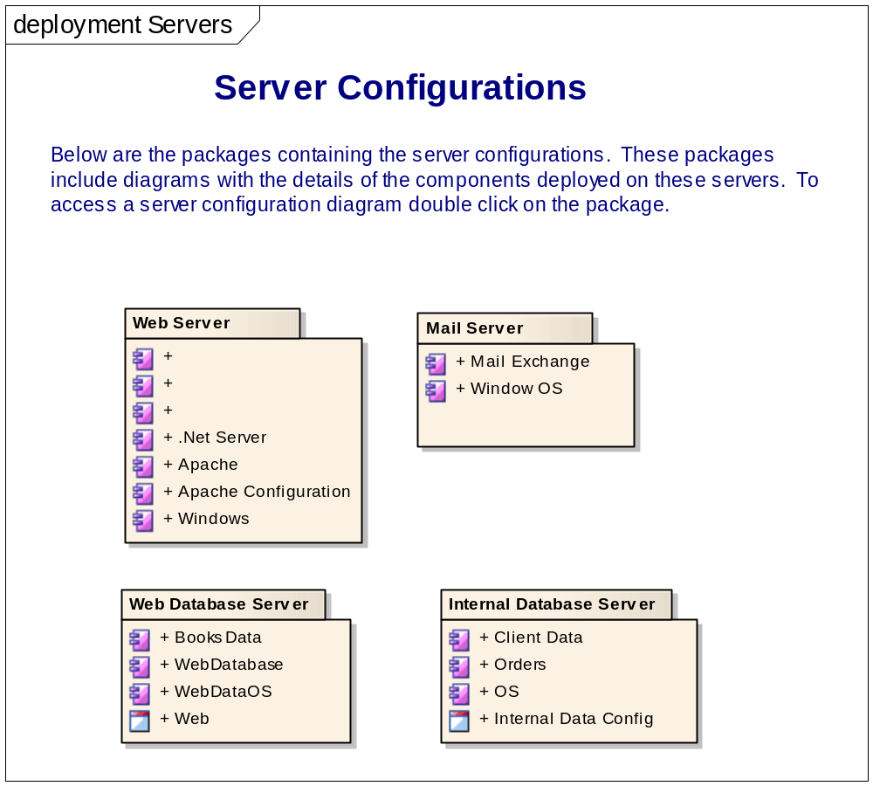
Figure 12: Servers

Text

Server Configurations

Internal Database Server

Internal Database Server

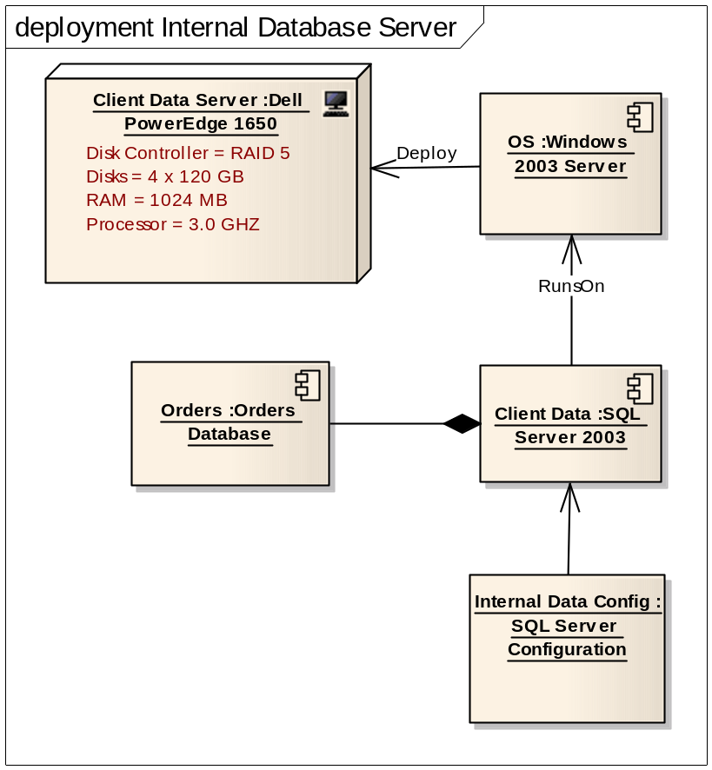
Figure 13: Internal Database Server

Internal Data Config

Client Data

OS

Orders

Mail Server

Mail Server

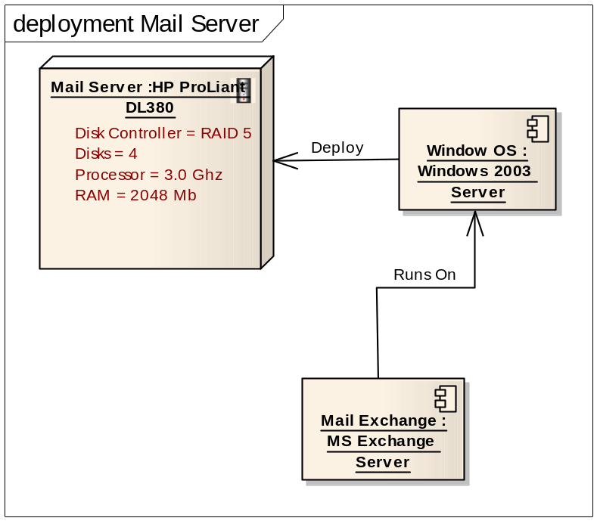
Figure 14: Mail Server

Mail Exchange

Window OS

Web Database Server

Database Server
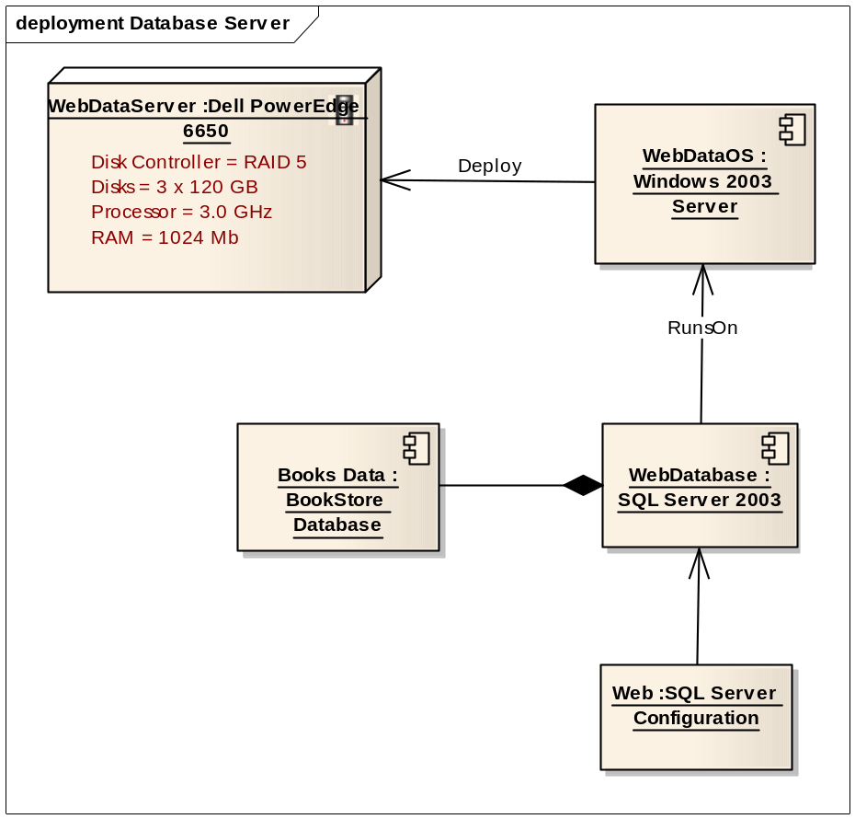
Figure 15: Database Server

Web

Books Data

WebDataOS

WebDatabase

Web Server

Web Server

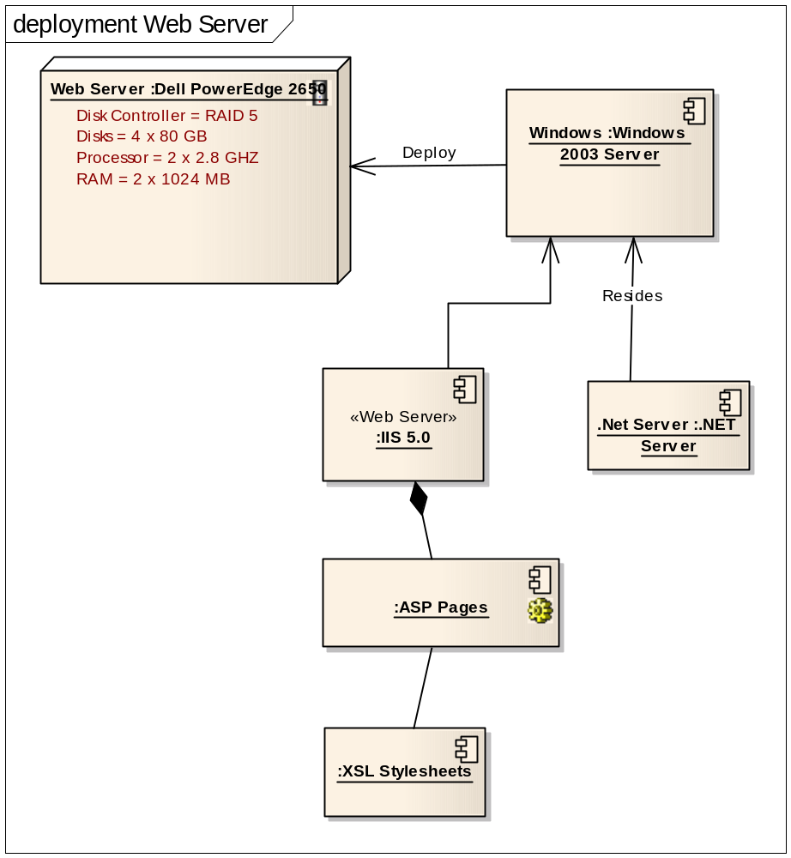
Figure 16: Web Server

.Net Server

<anonymous>

<anonymous>

<anonymous>

Apache

Apache Configuration

Windows

Windows 2003 server software is used for operating systems on the Web server.

Nodes

Computers

Clients

Desktop PC

LAN Client

Mail Client

Office Notebook

Remote Client

Remote Notebook

Servers

Dell PowerEdge 1650

1 Rack UnitDual Processor Capable3 Hot Plug Drive BaysRedundant Power Supplies

Dell PowerEdge 2650

2 Rack UnitsDual Processor Capable5 Hot Plug Drive BaysRedundant Power Supplies

Dell PowerEdge 350

1 Rack UnitSingle Processor Capable2 Non-Hot Plug Drive BaysNon-Redundant Power Supplies

Dell PowerEdge 6650

4 Rack UnitsQuad Processor Capable5 Hot Plug Drive BaysRedundant Power Supplies

HP ProLiant DL320

1 Rack UnitSingle Processor Capable2 Non-Hot Plug Drive BaysNon-Redundant Power Supplies

HP ProLiant DL360

1 Rack UnitDual Processor Capable2 Hot Plug Drive BaysRedundant Power Supplies

HP ProLiant DL380

2 Rack UnitDual Processor Capable6 Hot Plug Drive BaysRedundant Power Supplies

IBM xSeries 345

2 Rack UnitDual Processor Capable5 Hot Plug Drive BaysRedundant Power Supplies

IBM xSeries 360

3 Rack UnitQuad Processor Capable6 Hot Plug Drive BaysRedundant Power Supplies

Networking

ADSL Router

Ethernet Adaptor

Ethernet Hub

Ethernet Switched Hub

Intel 19510 Frame Relay Router

Packet Filtering Router

WatchGuard III Firewall

Operating Systems

Mac OS X

RedHat Linux 9.0

Sun Linux JVM 1.4.0

Windows 2000 Professional

Windows 2000 Server

Windows 2003 Server

Windows XP Professional

